5th Assignment English II Presentation and Discussion Autumn 2022
Lecture: Air Pollution
You can watch the video with subtitles on YouTube at this link. (https://youtu.be/kEYYFOYf6z8).
Watch the video. Read pages 1-5. Study the notes on page 6. Write a summary of the lecture on page 7. In your summary, try to use the language expressions taught on pages 1-5. Don’t copy sentences from the lecture. A summary should be short and written in your own words. Rename this document with a new file name (your last name-your first name-date.docx), then send the document to the teacher as an email attachment.
This lecture explains the causes and effects of air pollution, and ways to reduce the effects of air pollution in big cities.
There are many ways to explain causes and effects. Look at these various patterns which use cause and result as either a noun or a verb.

The cause of X is Y. The cause of lung cancer is smoking.
Y causes X. Smoking causes lung cancer.
X is caused by Y. Lung cancer is caused by smoking.
The result of Y is X. The result of smoking is lung cancer.
Y results in X. Smoking results in lung cancer.

This is a diagram from the lecture. It helps you understand what the teacher talks about in the video.
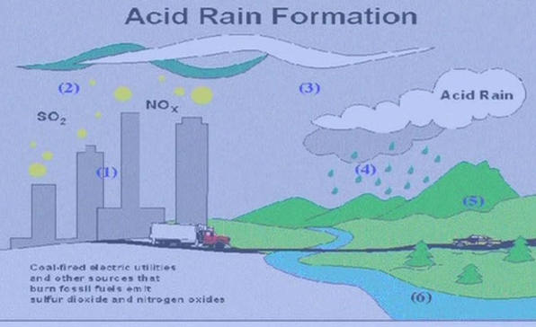

Chemistry Vocabulary Needed to Understand Air Pollution

Solutions with a pH less than 7 are acidic and solutions with a pH greater than 7 are basic (alkaline).

hydrogen H  carbon C  nitrogen N  sulfur S  oxygen molecule O2  ozone O3  carbon monoxide CO  carbon dioxide CO2  sulfur dioxide SO2 | atom  molecule  acid (n.)  acidic (adj.)  acidify (v.)  basic (alkaline)  pH

Cause and Effect

1. Active Voice
- Burning fuel produces CO2.
- The use of fossil fuels causes global warming
- The use of electricity leads to acid rain.
- Acid rain results in deadly acid levels in lakes.
- Acid rain affects the fish living in lakes.

2. Passive Voice
- CO2 is produced by burning fossil fuel.
- Global warming is caused by the use of fossil fuels.
- Fish living in lakes are affected by acid rain.

3. Nouns
- Acid rain has a harmful effect on fish.
- The cause of acid rain is the burning of fossil fuels.
- The energy crisis is producing a deadly result.
- Every form of energy production has a negative effect on the environment.

4. Conjunctions relating cause and effect
- Global warming happens because of burning of fossil fuels.
- All the fish in the lake died because people in this region used coal to produce electricity.
- They used large amounts of coal, so of course acid rain became a serious problem.
- The government forced the energy companies to install expensive chimneys so that they would release less SO2 and NO2. (so that expresses the purpose of an action, or the intention behind an action)
- The government forced the energy companies to install expensive chimneys in order to reduce the acid rain problem.

1. Language Structures for Explaining Cause and Effect

a. Active Verbs

this causes... this leads to... this results in... this affects... this produces + NOUN (DIRECT OBJECT)

b. Passive Verbs

this is caused by… this is affected by… this is produced by… + NOUN (SUBJECT)

c. Nouns

the cause is… the result is… the effect is…

2. Conjunctions explaining cause and effect

- X happens because of Y [because of + NOUN]
- X happened because Y happened [because + S + V]
- Y happened, so X happened
- X happened so that Y would happen [so that explains the purpose of the action X]
- X did Y in order to + VERB [this is a way to explain the purpose of the action Y]

You can also explain cause, effect and a second effect with sentences that follow this logical pattern:

If A, then B, so C OR When A, then B, so C

If (A) you work too much overtime, then (B) you become very tired, so (C) you actually don’t produce more just because you work a longer time. When (A) you get too tired, then (B) you will make more mistakes, so (C) sometimes it is better to stop working and come back to work when you are rested. [then is often omitted in speaking and writing]

3. Explain a sequence of causes and effects

first, then, next, finally

4. Feedback loops

A series of causes and effects sometimes becomes a feedback loop. This is called either a negative or positive feedback loop, or a vicious circle or a virtuous circle. It is also called an upward or downward spiral.

A vicious (bad) circle or a virtuous (good) circle?

As humans burn more fossil fuel, the planet becomes warmer. This results in more ice and snow melting. Then the atmosphere becomes warmer because there is less white snow reflecting solar energy back toward space. This is an example of a vicious circle or negative feedback loop. The effects become additional causes of the original problem, so the problem gets worse at an exponential (non-linear rate) rate. In economics there are many other examples. A factory closes → The former workers spend less money in stores → Stores close… A virtuous circle moves in the opposite way. A factory opens → More people come to a town to work in the factory → New stores open…

On a graph, a linear effect appears as a straight line. An exponential effect appears as a curved line. In the equation 4³ = 64, 3 is the exponent. Feedback loops always show an exponential relationship between causes and effects, so the line of a graph explaining a problem like global warming is a curve showing the exponential relationship. It could be shown in its simplest form as a=b^{c} .

Cause and Effect, Causal Relationships
Feedback Loops, Spirals and Vicious & Virtuous Circles: The Greenhouse Effect

Everyone knows that if you sit in a car on a summer day with the windows closed, you will begin to feel very hot. The energy from the sun comes through the glass and into the car, but it doesn’t go back out fast enough, so the car heats up. The glass causes the temperature to go up. Farmers create a warm space in the same way by making a greenhouse in order to grow vegetables in the winter.
Global warming is caused by a similar process, so this is the reason it is sometimes called the “greenhouse effect.” In this case, it is increasing levels of gasses such as CO2 that are like the glass or plastic of a greenhouse. Sunlight comes to earth, but the heat doesn’t go back out to space as much as it used to. The CO2 has the same effect as the glass windshield of a car, and this leads to higher temperatures.
Exponential: 指数関数 Non-linear: 非線形

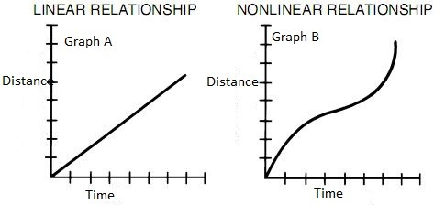

Non-linear, exponential relationship
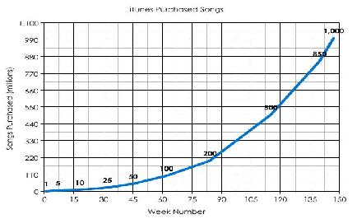

Spiral pattern: It starts small and gets bigger at each repetition of the circle.

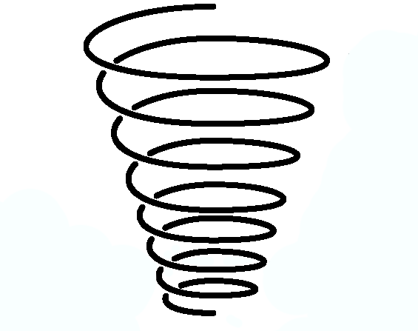

Unique Solutions to Pollution
Notes
Use these notes to write a summary of the lecture on the next page.
1. air pollution
a. one harmful gas - SO₂
b. trees - low technology solution
2. urban areas
a. high pop. = high pollution
b. 50% of world’s pop. (3 bill. in 2005) lives in cities
c. cities are important in solving air pollution
3. causes
a. SO₂ (1 sulfur + 2 oxygen atoms) from fuel
4. SO₂ process
fuel is burned, S goes into air, mixes with O → SO₂ , mixes with water in clouds → sulfuric acid, mixes with other gases → sulfates → acid rain → harms fish and ecosystems
5. effects of SO₂ on people
a. breathing, watering eyes, burning nose and throat
b. temporary or permanent damage
6. effects of SO₂ on environment
a. plants, soil
b. acidic water harms fish
7. solutions
a. trees in urban areas, urban forests - ex. school yards, parks, along highways
b. trees absorb polluting gases, like a sponge
c. cooling effect, so less air conditioning used, so less SO₂ from electricity generators
d. Beijing, Dublin, Mexico City - urban forestry programs

Use these notes to write a summary of the lecture on the next page.

Summary of the Lecture

