English II Presentation and Discussion
Autumn 2022, Mondays 14:40-16:10
7th Assignment

Step 1: Watch this segment of the film King Corn.
(14 minutes, subtitles in English and Japanese) https://youtu.be/OxOGerLBF2w
Step 2: Read the background information below (page 2).
Step 3: Take notes as you listen to the segment of the film again.
Step 4: Do the exercise on page 3.

KING CORN

A documentary film directed by Curt Ellis and Ian Cheney, Bullfrog Films, 2007
King Corn is a feature documentary about two friends, one acre of corn, and the crop that supplies the fast-food industry. In the film, Ian Cheney and Curt Ellis, best friends from college, move to Iowa, in the center of the United States, to learn where their food comes from. When they try to follow their corn into the food production system, what they find raises troubling questions about what we eat.
http://www.kingcorn.net/the-film/synopsis/

Background Information
Types of sugar and theories about the causes of obesity
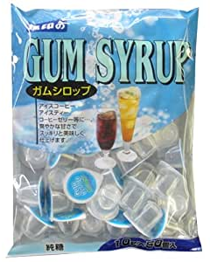 | 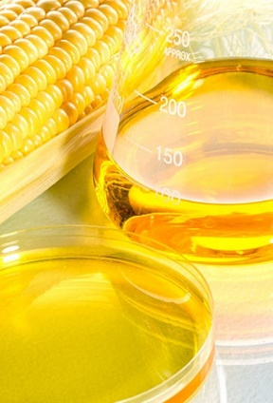 |  | 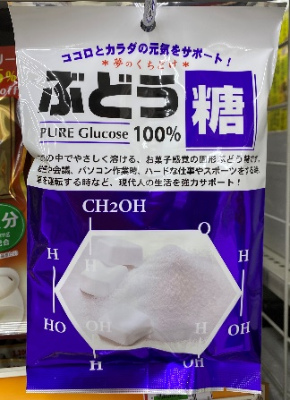

“Gum Syrup” is a common sweetener sold in Japan, similar to high fructose corn syrup (HFC). In some countries, HFC is called isoglucose syrup. It contains fructose (果糖) and glucose (ブドウ糖), and it is made from starchy foods like potatoes and corn, or from sugar cane (sucrose 蔗糖). Fructose is also the kind of sugar in fruit and honey. Fructose leads to serious health problems if there is too much in the diet because it changes into fat in the human body. Glucose, like fructose, is also a sugar that has “empty calories,” but it doesn’t become fat in the body. White powdered sugar, the most common type of sugar before 1970, is sucrose (蔗糖). Sucrose is a combination of one fructose molecule and one glucose molecule.
Because sucrose and HFC both contain almost equal amounts of glucose and fructose, the makers of HFC say it is wrong to say that HFC is much worse than sucrose.
However, in the past, food and drink companies used corn syrup (not HFC) to sweeten their products, and corn syrup contains only glucose—and no fructose. This may be one reason obesity was not a big problem in the past. When HFC came into the food supply, it was cheap and plentiful, so it replaced corn syrup in the food supply, and as a result, people started to consume much more fructose. Fast food restaurants and convenience stores started selling soda drinks very cheaply. They offered “super-size” cups and free refills. HFC became a public health problem not so much because of its chemical composition (glucose + fructose) but because it was cheap, plentiful and overused, which resulted in much more fructose going into human stomachs.
In spite of the fact that it is unhealthy to eat too much sugar, scientists have other theories about why obesity started to rise dramatically after 1970. These theories consider factors such as changing human behavior or environmental pollution causing hormonal imbalances and genetic damage.
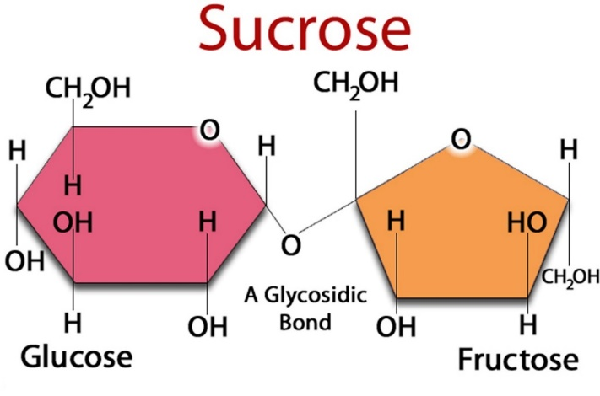 | 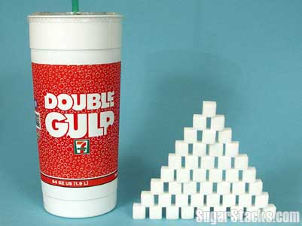
 | 7-11 Double Gulp Sweet Soda, 1.9 liters.

Use your notes to write a short answer that explains each point (1-10).

1 | Agriculture policy in the United States before 1970
2 | Agriculture policy in the United States since 1970
3 | Factors that made corn production increase after 1970
4 | High fructose corn syrup (HFC): What is it? Why was it put into so many kinds of foods and drinks?
5 | Good points of HFC
6 | Bad points of HFC
7 | How corn has changed since it first came from Mexico
8 | Drinking calories, no stop signal
9 | Empty calories
10 | Frey Mendez (taxi driver): his story and his family’s story

The people who appear in the segment of the film
Ian Cheney and Curt Ellis (narrators and filmmakers)
Ken Cook (Environmental Working Group)
Audrae Erickson (Corn Refiners Association)
Loren Cordain (Professor, University of Colorado)
Ricardo Salvador (Professor, Iowa State University)
Walter Willet (Professor, Harvard University)
Farida Khan (Medical Doctor, MD)
Sabita Moktan (Medical Doctor, MD)
Frey Mendez (Taxi Driver)

